5G INTERNET AND AUTOMATION

MA69001 SEMINAR REPORT

submitted by

MAURYA RAJKUMAR RAMASARE
21MA60R33
Master of Technology
COMPTUTER SCIENCE AND DATA PROCESSING

DEPARTMENT OF MATHEMATICS

Indian Institute of Technology Kharagpur (IIT-KGP)
West Bengal 721302, INDIA

ACKNOWLEDGEMENT

I would like to express my sincere gratitude to Dr. P V S N Murthy, Seminar coordinator for his constant support, invaluable guidance and encouragement during the entire period of this work.

I am also grateful for the support of Dr. Somnath Bhattacharyya, Head of the Department, Department of Mathematics, Indian Institute of Technology Kharagpur.

I would like to express my thanks to Dr. Sourav Mukhopadhyay, Faculty Advisor, Department of Mathematics, Indian Institute of Technology Kharagpur, for extending his support in the completion of this work.

MAURYA RAJKUMAR RAMASARE
02 November 2021

Contents Page No.

ABSTRACT 4
1) Introduction 5
1.1) Expectation for the 5G era and opportunity 6
1.2) comparison with other networks 7
1.3) 5G design and planning considerations 8
1.4) 5G architecture diagram 9
1.5) The evolution of 5G 10
1.6) key features of 5G networks 11
1.7) intelligent automation and economic contribution of 5g networks 12
2) Applications: 14
2.1) 5G is not just faster, but a new paradigm 14
2.2) Standards benefit consumers and companies as they lower investment 14
and deployment costs, facilitate connectivity and foster interoperability
2.3) Multiple spectrum bands are required to address the wide range of 5G use cases and applications 15
2.4) 5G is more than just business: It will have an induced impact on key socioeconomic issues 16
2.5) The industries that will leverage 5G to renew their business models and create more value 16
3) why there is need of 5g? 18
4) Advantages of 5G network of the Master Core technology 19
4.1) Quality of Service (QoS) 19
4.2) Exceptional applications 20
4.3) Cloud computing 20
4.4) 5G INTERFACING UNIT 20
5) Automation in electric vehicle 21
Machine learning algorithm types
6) SUMMARY OF REPORT ON 5G TECHNOGY 25
6.1) Future directions and enhancement 26
CONCLUSION 27
REFERENCES 28

ABSTRACT

5G Technology will become the backbone of many tech. or non tech. industry such as technologies like Artificial intelligence, robotics, security issue, augmented reality/virtual reality, drones, telemedicine, autonomous vehicles, data traffic capacity, Cloud computing, Internet of things (IoT) and software-defined networking (SDN) have become some of the core technologies for the 5G network.

The mobile industry is developing and preparing to deploy the fifth-generation (5G) networks. The evolving 5G networks are becoming more readily available as a significant driver of the growth in IoT and other intelligent automation applications.

5G is lightning-fast connection with low-latency are utilizes for advances in intelligent automation such as Internet of Things (IoT), Artificial Intelligence (AI), driverless vehicles, digital reality, blockchain, and future breakthroughs we have not even thought of yet.

The advancement of 5G is not just a generation upgradation, it opens a new world of possibilities for every tech industry. The purpose of this seminar report is to do a literature review and explore how 5G can enable or streamline intelligent automation in different industries. And different types of applications along with challenges for human being.

- Introduction

- 5G Technology stands for 5th Generation Mobile Technology. 5G technology has changed to use cell phones within very high bandwidth. 5G is a packet switched wireless system with wide area coverage and high throughput. 5G technologies use CDMA and BDMA and millimetre wireless that enables speed is greater than 100Mbps at full mobility and higher than1Gbps at low mobility. The 5G technology provides the mobile phone users more features and efficiency. A user of mobile phone can easily connect their 5G technology gadget with laptops or tablets to acquire broadband internet connectivity. Up till now following features of the 5G technology have come to surface- High resolution is offered by 5G for extreme mobile users, it also offers bidirectional huge bandwidth, higher data rates and the finest Quality of Service (QoS).

- 5G technologies were developed to accommodate the increasing demands for mobile data (i.e., more people using more data on more devices). 5G technologies are expected to serve current consumer demands and future applications (e.g., industrial Internet of Things, autonomous vehicles). 5G technologies are expected to yield significant consumer benefits (e.g., assisting the disabled or physical challenged, enabling telemedicine) industrial benefits (e.g., automated processes, increased operational efficiencies, data analytics) and economic benefits (e.g., new revenues, new jobs).

IMPORTANT APPLICATION
- Untethered industrial robots
- Internet of things (IoT)
- Robots in surgery
- Virtual patient operations (telesurgery)
- AI in diagnosis
- Self-driving vehicles
- Robots fighting Covid-19
- 5G drone taxis
- Virtually attend the Oscars
- Monitoring forests with 5G
- Cloud computing
- AI in space technology

  - Expectation for the 5G era and opportunity.

5G is the next generation mobile technology and will transform the role of mobile in society.
The 5G era will commence in India very soon, creating huge opportunities for consumers, enterprises, operators, vendors and all stakeholders.
To deliver on its promises, the mobile industry has five clear goals for the 5G era:
- Provide boundless connectivity to all
- Deliver sustainable network economic & innovations.
- Transform the mobile broadband experience.
- Drive growth in new use cases for massive and critical IoT system.
- Accelerate the digital transformation of industry verticals.

Deploying 5G is an opportunity for operators to move beyond connectivity and collaborate across sectors such as finance, transport, retail and health to deliver new, rich services to consumers and businesses. It is an opportunity for industry, society and individuals to give advancement in their digital ambitions, with 5G a catalyst for innovation.

5G will naturally evolve from existing 4G networks, but will mark an inflection point in the future of communications, bringing instantaneous high-powered connectivity to billions of devices.
It will be designed specifically for the way users want to live and will provide a platform on which new digital services and business models can thrive. It will enable machines to communicate without human intervention in an Internet of Things (IoT) capable of driving a near- endless array of services. It will facilitate safer, more efficient and cost-effective transport networks. It will offer improved access to medical treatment, reliably connecting patients and doctors all over the globe.

From low-power, sensor-driven smart parking to holographic conference calls, 5G will enable richer, smarter and more convenient living and working. It is a giant step forward in the global race to digitise the economy and societies.

  - Comparison with other networks

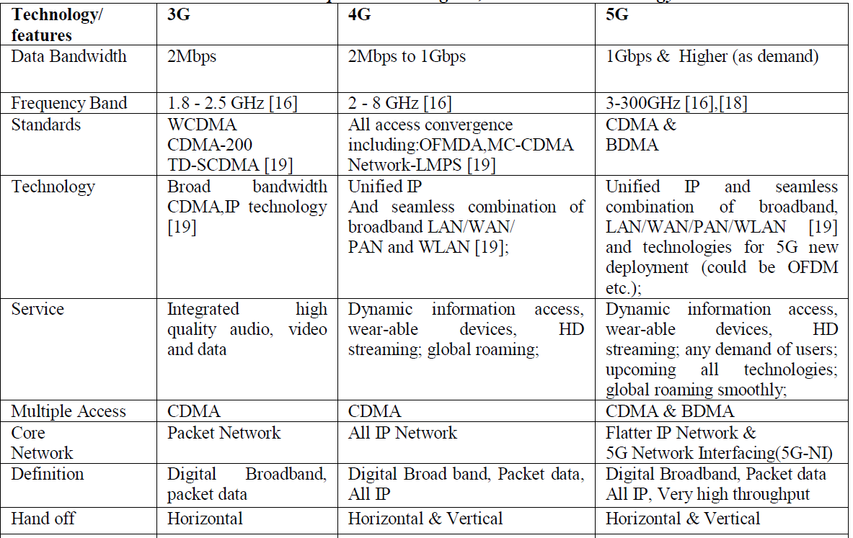

  - 5G Design and planning considerations

The plan contemplations for a 5G organization engineering that upholds profoundly requesting applications is perplexing. For instance, there is nobody size-fits all methodology; the scope of uses expects information to travel distances, huge information volumes, or some blend. So 5G engineering should uphold low, mid and high-band range – from authorized, shared and private sources – to convey the full 5G vision.

Consequently, 5G is architected to run on radio frequencies going from sub 1 GHz to very high frequencies, called 'millimeter wave' (or mm Wave). The lower the recurrence, the farther the sign can travel. The higher the recurrence, the more information it can convey.
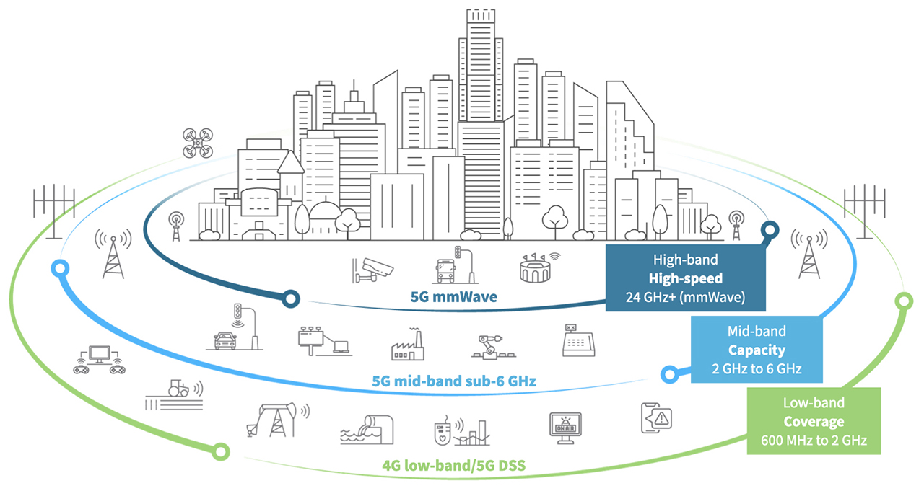

1.4 5G Architecture Diagram
5G was designed from the ground up, and network functions are split up by service. That is why this architecture is also called 5G core Service-Based Architecture (SBA). The following 5G network topology diagram shows the key components of a 5G core network:
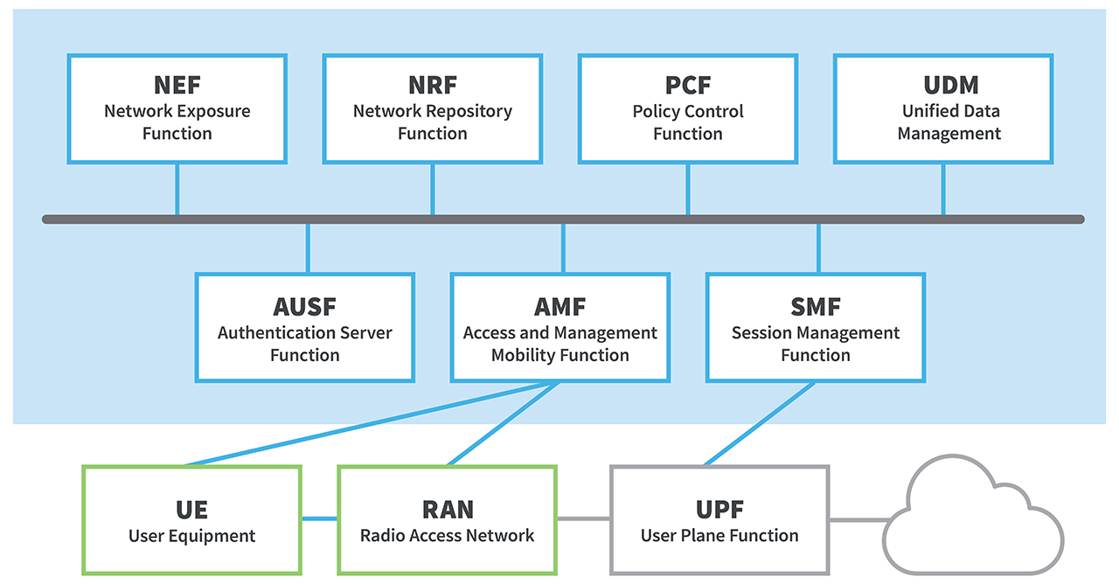
working analysis:
- User Equipment (UE) like 5G smartphones or 5G cellular devices connect over the 5G New Radio Access Network to the 5G core and further to Data Networks (DN), like the Internet.
- The Access and Mobility Management Function (AMF) acts as a single-entry point for the UE connection.
- Based on the service requested by the UE, the AMF selects the respective Session Management Function (SMF) for managing the user session.
- The User Plane Function (UPF) transports the IP data traffic (user plane) between the User Equipment (UE) and the external networks.
- The Authentication Server Function (AUSF) allows the AMF to authenticate the UE and access services of the 5G core.
- Other functions like the Session Management Function (SMF), the Policy Control Function (PCF), the Application Function (AF) and the Unified Data Management (UDM) function provide the policy control framework, applying policy decisions and accessing subscription information, to govern the network behaviour.

1.5 The Evolution of 5G
- Every generation of wireless communication takes approximately a decade to establish. The switch from one generation to the next is mainly driven by the operators need to response the limited amount of available spectrum. Each new generation has more spectral efficiency, which makes it possible to transmit data faster and more effectively over the network.

- The first generation of wireless communication(1G), started back in the 1980s with analog technology. This was followed quickly by 2G, the first network generation to use digital technology. The growth of 1G and 2G was initially driven by the market for mobile phone handsets. 2G also offered data communication, but at very low speeds.
- The next generation, 3G, began ramping up in the early 2000s. The growth of 3G was driven by handsets again, but was the first technology to offer data speeds in the range of 1 Mbps, suitable for a variety of new applications both on smartphones and for the emerging Internet of Things (IoT) ecosystem.

- Our current generation of wireless technology 4G LTE, began ramping up in 2010.
It is important to note that 4G LTE (Long Term Evolution) has a long life ahead. it is a very successful and mature technology and is expected to be in wide use for at least another decade.

1.6 Key features of 5G networks
- 5G networking standards
- Expanding the networking spectrum

Networking spectrum bands

- New technological innovations

5G networks capabilities.

1.7 Intelligent automation and economic contributions of 5G networks

Manufacturing industries are moving towards digitalization for several reasons, including increasing revenue by better serving their customers, increasing demand, beating the competition, decreasing costs by increasing productivity and efficiency, and decreasing risk by increasing safety and security. A recent study identified the key challenges and requirements in digitization industries digitization
These requirements range from:
- Ultra-reliable, resilient, instantaneous connectivity for millions of devices.
- Low-cost devices with extended battery life.
- Asset tracking throughout the ever-changing supply chains.
- Performing remote medical procedures.
- Using AR/VR to enhance the shopping experiences.
- Using AI to enhance operations in multiple areas
- enterprise-wide.

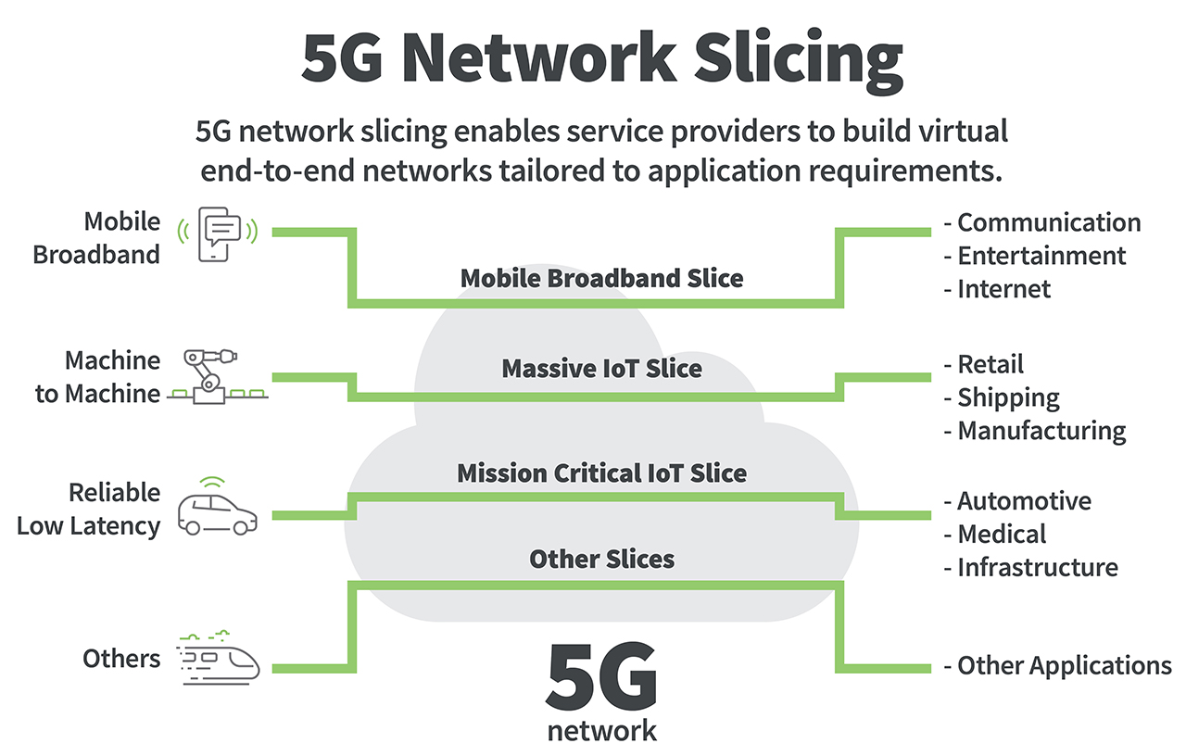

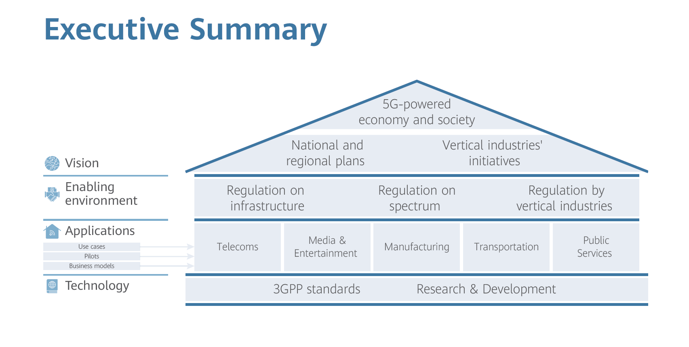
New 5G applications are emerging, supported by national strategies:
- Telecom: 5G for home (e.g., Fixed Wireless Access) and mobile

- Media: AR/VR gaming, and advertising, multi- broadcasting

- Manufacturing: Smart factories & connectivity over the full product lifecycle

- Transportation: autonomous driving, in-car infotainment

- Public services: healthcare (e.g., telemedicine), education
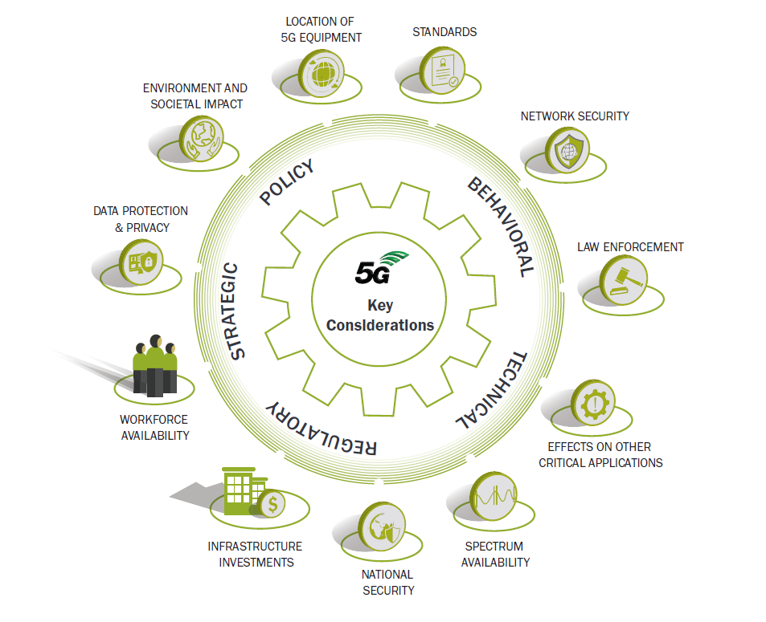

2. Applications

2.1 5G is not just a faster, but a new paradigm

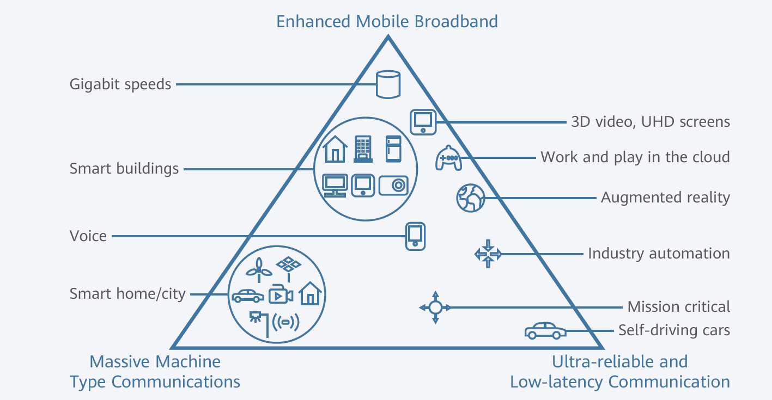
Three pillars of 5G and examples of related use cases
Built on 3 main pillars, 5G will create tremendous opportunities:
- Enhanced Mobile Broadband (eMBB) will provide mobile network customers and industrial users with enhanced capacities, entertainment and media, and other service sectors.

- Ultra-reliable and Low-latency Communication (URLLC) will support new applications (e.g., autonomous driving, remote surgical operation, industry automation). Massive Machine-type Communications (mMTC) will enable industry players to connect massive numbers of devices with specific connectivity requirements, in sectors such as manufacturing, utilities, and logistics.

- Equipment vendors develop 5G technologies, define and introduce 5G products (RAN, core network, services, handsets).

- Industry stakeholders are brought into the paradigm by the new opportunities with 5G. Many sectors are involved because 5G will enable massive innovation both on the product side (e.g., connected vehicles) and on the productivity side (e.g., industrial IoT).

2.2 Standards benefit consumers and companies as they lower investment and deployment costs, facilitate connectivity and foster interoperability.
5G standards will ultimately be required for microprocessors, devices, and device modules, as well as the 3 main layers of network infrastructure:
- Core network, the backbone of network exchanges, gathering and dispatching data packages
- Radio Access Network, made up of equipment that links the core network to user devices
- Services and systems, overall architecture and service capabilities

Each of these layers requires the coordination of multiple hardware and software elements that were developed by independent technology vendors. Interoperability amongst them is necessary to ensure good network performance and economic efficiency in production. Technical standards aim to ensure inter-operability.

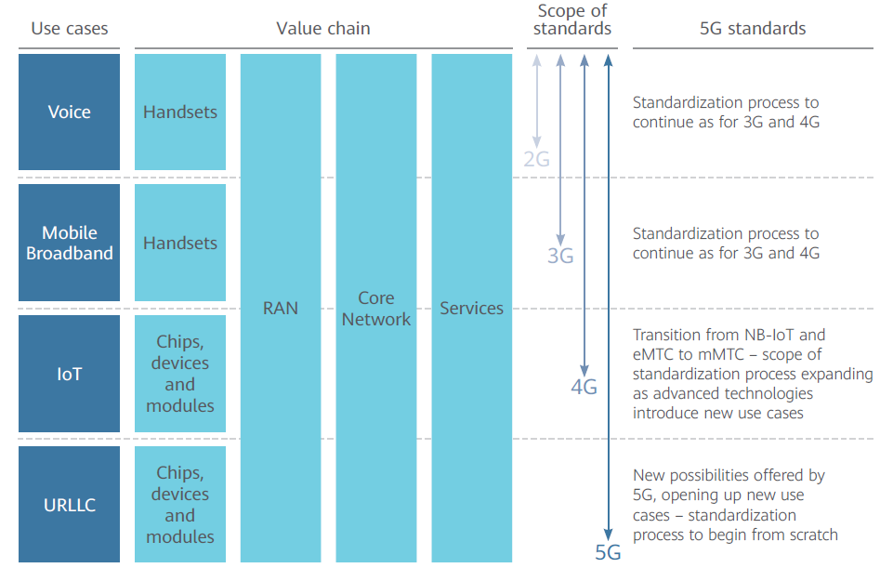

2.3 Multiple spectrum bands are required to address the wide range of 5G use cases and applications
Spectrum harmonization between national regulatory authorities would support 5G development and spread of 5G applications, as harmonization enables economies of scale, facilitates cross-border coordination and roaming for end users.
A multi-layer spectrum approach is required to address the wide range of 5G use cases:
- The Coverage Layer exploits spectrum below 2 GHz providing wide-area and deep indoor coverage. When used in combination with bands in the 3.3 to 3.8 GHz range, the pairing allows operators to benefit from their features, thus delivering enhances capacity and coverage.
2.4 5G is more than just a business: It will have an induced impact on key
Socio economic issues
Traditional broadband, hardware, and services revenue for telecom operators is expected to grow at 1% p.a. 5G will bring new opportunities for mobile operator and will drive an estimated growth of 3% p.a. for the telecommunications industry as a whole. 5G will make up 80% of service provider revenues, due to new business opportunities (industrial applications) and substitution of current 2G/3G/4G mobile broadband revenues.
5G represents tremendous opportunities for the economy and all members of society: consumers, homes, businesses, and communities. The potential of savings and improved efficiency of new technologies will trigger the democratization of many services. Connectivity will bring more information and education to all populations. New business opportunities across many different industries will boost investment and employment. By expanding the scope of wireless technologies and making devices more autonomous, 5G will help with the long-term objective of reducing our carbon footprint and conserving natural resources. 5G will be more inclusive, progressive, proven and powerful than any previous generation of communications technology.

2.5 The industries that will leverage 5G to renew their business models and create more value
There are a number of industries with particularly intense dynamics and business opportunities around 5G: telecommunications, media and entertainment, manufacturing, transportation and public services. Each of these sectors has specific business issues linked to 5G and its potential use cases.
2.5.1 Telecommunications
Telecom stakeholders are the frontrunners in pursuit of 5G opportunities, which will represent the majority of their revenues at the 2020–2025 horizon. 5G may be a solution to some of the problems the telecommunications industry currently faces, including the growth in data consumption. mobile operators aim to improve the total efficiency of data provision to customers by building more capacity.

2.5.2 Main 5G opportunities
Currently, telecoms stakeholders are focusing on creating new and expanding 5G coverage at a national scale, starting with local pilots. Superfast Fixed Wireless Access (FWA) is an opportunity to help governments to deliver on the promise of high-quality, universal broadband access to homes, especially in low density areas.
Edge computing as an evolution of cloud computing brings computation and data storage closer to the location where it is needed. It is expected that edge computing will play an essential role in the transformation of the telecommunications business: wireless carriers have a big advantage in the edge-computing race, as they control access to 5G high speed telecommunication networks.

2.5.3 5G network requirements
While 4G can reach speeds up to 100 Mbps, it is expected that 5G will enable speeds up to 1 Gbps, changing the scale at which telecommunications currently operates. With more power and improved efficiency, 5G may be the pathway towards connecting the world with greater ease.
Fixed wireless broadband networks using mainstream LTE-Advanced technology are proving capable of delivering fast, high-quality connectivity.
5G networks are a future environment for Multi-access Edge Computing (MEC) deployments. MEC applications interact with the 5G system to influence the routing of traffic for edge applications and to obtain notifications of relevant events, such as mobility events, for improved efficiency and a better end user experience.
2.5.4 Media and entertainment
Media and entertainment are one of the first sectors in which 5G will be widely used. Use cases will be deployed immediately. 5G can provide high quality audio-visual services and the ability to share live-videos over social media.

2.5.5 Manufacturing
Industry 4.0 is expected to be fuelled by cyber physical systems and the Internet of Things, which will require the support of 5G networks. This will enable the efficient, connected, flexible factories of the future.

2.5.6 Main 5G opportunities
Inside factories, 5G will facilitate manufacturing procedures, including more efficient production lines (e.g., with machine vision, and high-definition video for managing processes), autonomous transportation and machine control, with latency of less than 5 ms.
Outside factories, 5G could help the manufacturing sector to improve product lifecycle management, for example by enabling predictive maintenance and bringing responsive design to products. Communication between companies can also be facilitated by 5G, enabling better end-to-end tracking of goods at lower cost, or data exchanges for simulations or collaborative design.

2.5.7 5G network requirements
Indoor mission–critical processes have stringent requirements. In order to deliver ultra-low latency and ultra-high reliability in a heterogeneous environment, further enhancements to 4G and 5G technologies will be necessary.
Exploiting product lifecycle data from connected goods will also require new technologies, featuring minimal energy consumption, ultra-high autonomy, and low subscription costs.

3. WHY THERE IS NEED OF 5G?
It could make better revenue for current global operators as well as interoperability will become more feasible.
Improved and innovative data coding and modulation techniques, which includes filter bank multi carrier way in schemes.
For wireless access and back haul use of millimetre wave frequencies is very useful.
With the support of different conduction points with related coverage and surrounding the option of a supple usage of resources for uplink and down link transmission in each cell is achieved by superior intrusion and mobility management.
To make 5G practical for all sorts of radio access technologies there should be a common platform unique for all the technologies.
Lower battery consumption and outage probability.
Better coverage and high data rates available at cell edge.
Multiple concurrent data transfer paths.
Possible to 1Gbps and higher data rate in mobility.
More secure, better cognitive radio/SDR Security.
Higher system level spectral efficiency.
World Wide Wireless Web (WWWW), wireless-based web applications that include full multimedia capability beyond 4G speeds.
More applications combined with Artificial Intelligent (AI) as human life will be surrounded by artificial sensors which could be communicating with mobile phones.
Cheaper traffic fees due to low infrastructure deployment costs.
Smart beam antenna systems.

5G is to be a new technology that will provide all the possible applications, by using only one universal device, and interconnecting most of the already existing communication infrastructures. The 5G terminals will be an upgradable multimode and cognitive radio- enabled. It will have software defined radio modulation schemes. All the required upgradable software should be downloaded from the Internet on the run. The 5G mobile networks will focus on the development of the user terminals where the terminals will have access to different wireless technologies at the same time and will consolidate various flows from various technologies. Besides, the terminal will make the ultimate choice among different wireless/mobile access network providers for a given service.

4. Advantages of 5G network of the Master Core technology
The Master Core technology has been designed for boundless wireless service so that computer, entertainment devices and mobile phone may all share the same wireless network and can be connected with internet anytime, anywhere. It is designed for 5G communication system to fulfil the limitless target up to the next two centuries, the common features as following.
Files can be downloaded (even movies) within seconds.
Pages will upload almost instantly, can play easily online games.
5G devices are comparatively less expensive than 3G and 4G devices.
Finest Quality of Service (QoS).
All Networks can be gathered on a platform.
New deployments of 5G can be connected directly with The Master core by 5G -IU (5G Interfacing Unit) without All IP concept.
No limitation as user demands, Ability to support the new services.
The Master Core’s hardware and software are upgradeable.
Remote PCs can be controlled by handsets.
Subscriber can use application software without installation in own devices that provided by the MasterCore.
The MasterCore can manage all securities types and distributed in several layers.
The high-quality services of 5G technology based on Policy to avoid error.
4.1 Quality of Service (QoS)
Quality of Service (QoS) refers to a networks ability to achieve maximum bandwidth and deal with other network performance elements like low latency, error rate and uptime. Quality of service also involves controlling and managing network resources by setting priorities for specific types of data (video, audio, files) on the network. QoS is exclusively applied to network traffic generated for video on demand, streaming media, videoconferencing and online gaming. The primary goal of quality of service is to provide priority to networks, including dedicated bandwidth, low latency and improved loss characteristics. Its technologies supply the elemental building blocks that will be used for future business applications in campus, wide area networks and service provider networks. There are three fundamental components for basic QoS implementation.
- Identification and marking techniques for coordinating QoS from end to end between network elements.
- QoS within a single network element.
- QoS policy, management, and accounting functions to control and administer end-to-end traffic across a network.

4.2 Exceptional applications
The 5G Master Core has some exceptional applications with common features as;
One can know weather, temperature, and location etc. of each other when conversation is going on.
Students can attend any class of any institute of the world without going there through online.
A doctor can treat patients of other countries from a place.
Possible to monitor any place of the world from anywhere.
Batteries can be charged by using network without charger.
It could be possible to visualize lively all the planets and the Universe.
One can complete his/her works without going to the office.
One can be able to locate his/her child when she/he is unfortunately missed.
government can be able to predict tsunami/earthquake before it occurs.

4.3 Cloud computing
Cloud computing is a model for enabling ubiquitous, convenient, on-demand network access to a shared pool of configurable computing resources (e.g., networks, servers, storage, applications and services) that can be rapidly provisioned and released with minimal management effort or service provider interaction. Hence, cloud computing is a technology that uses the internet and central remote server to maintain data and applications. In 5G networks this central remote server could be a content provider. Cloud computing allows consumers and business to use applications without installation and access their personal files at any computer with internet access. The same concept is going to be used in multi-core technology where the user tries to access his private account form a global content provider through cloud computing.

4.4 5G INTERFACING UNIT
5G Interfacing Unit acts to make the most powerful of 5G wireless communication system. Because, all sorts of radio access technologies are combined in a common platform is complex form of aggregation. It will be more complex in future when added new radio access technologies. This is why, 5G-IU is used between new deployments and core network so that 5G wireless communication system is easily manageable. It has some advantages are:
- Lower costs to establish networks.
- Lessen equipment’s.
- Improve network efficiency.
- Reduce complexity.
- Easily maintain high security.
- Impossible to occur any trouble.

5. AUTOMATION IN ELECTRIC VEHICLE
AI is a calculation of the concentrated electronic control unit (CECU) in an independent vehicle, coordinating ML considerably further in self-driving vehicles to shape them cutting edge manifestations. One of the essential elements of ML calculations in an independent vehicle is to ceaseless observing of the general climate and precisely anticipating the potential changes to that encompassing.
Table of Contents
- The Four Sub-Tasks
- Machine Learning Algorithms For Self-Driving Cars
  - 1) Supervised ML algorithms
  - 2) Unsupervised ML algorithms
- Machine Learning Algorithms for Autonomous Cars
  - 1) Regression Algorithms
  - 2) Pattern Recognition Algorithms (Classification)
  - 3) Cluster Algorithms
  - 4) Decision Matrix Algorithms
- Conclusion

The Four Sub-Tasks
- Object detection
- Object identification/recognition
- Object localization
- Movement prediction

Self-driving vehicles typically consolidate various sensors that assist them with sorting out their environmental elements, including GPS, radar, sonar, odometry, and inertial estimation units. They likewise have progressed control frameworks that can decipher tactile data to recognize deterrents and sort out appropriate route ways.

The ML-based applications that run an independent vehicle get data from the sensor information combination frameworks and make forecasts likewise. These calculations can likewise incorporate the driver's signal, discourse acknowledgment, and language interpretation in the vehicle framework.

5.1 Machine Learning Algorithms classification For Self-Driving Cars

1) Supervised ML algorithms

These calculations use preparing dataset to learn. They continue to learn until they arrive at the ideal level that guarantees negligible mistakes. Managed ML calculations can additionally be arranged into order, relapse, and aspect decrease calculations.

The essential objective here is proportional the extent of information and to make forecasts about future results by handling and breaking down the named test information.

The most widely recognized use instances of managed learning are anticipating future patterns in value, deals, and stock exchanging. Instances of managed calculations incorporate Linear Regression, Logistical Regression, Neural Networks, Decision Trees, Random Forest, Support Vector Machines (SVM), and Naive Bayes.

Relapse – This procedure initially recognizes the examples in the example information and afterward ascertains or recreates the forecasts of persistent results. To do that, it needs to comprehend the numbers, their qualities, their connections or groupings, etc. Relapse can be utilized for pride forecast of items and stocks.

Characterization – In this method, the info information is marked as per the verifiable information tests and is then physically prepared to recognize specific sorts of items. When it figures out how to perceive wanted items, it then, at that point, figures out how to sort them properly. To do this, it needs to realize how to separate between the obtained data and perceive optical characters/pictures/parallel sources of info. Arrangement is utilized to make climate conjectures, distinguish objects in an image, decide whether a mail is spam or not, and so forth
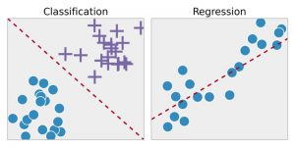

2. Unsupervised ML algorithms

These calculations learn by sorting out the current information. No preparation datasets are needed here. They attempt to find recogniisable examples inside the information and afterward partition the information into classes/bunches as per the degree of comparability between them. Bunching and affiliation rule learning are the two sorts of unaided ML calculations.

Not at all like managed learning approach that utilizations marked information to make yield forecasts, solo learning feeds and trains calculations solely on unlabelled information. The solo learning approach is utilized to investigate the inner construction of information and concentrate significant experiences from it. By distinguishing the secret examples in unlabelled information, this method means to uncover such experiences that can prompt better yields. It could be utilized as a fundamental stage for directed learning.

Solo learning is utilized by organizations to extricate significant experiences from crude information to work on functional productivity and other business measurements. It is normally utilized in the fields of Digital Marketing and Advertising. Probably the most famous solo calculations are K-implies Clustering, Association Rule, t-SNE (t-Distributed Stochastic Neighbor Embedding), and PCA (Principal Component Analysis).

Dimensionality Reduction – Dimensionality Reduction is utilized to track down a superior and conceivably less difficult portrayal of the information. Through this technique, the information is purified of the excess data (or if nothing else limit the pointless data) while holding every one of the fundamental pieces. Along these lines, it takes into account information pressure, consequently diminishing the extra room necessities of the information. One most normal use instance of Dimensionality Reduction is isolation and recognizable proof of mail as spam or significant mail.
3. Semi-supervised Learning
Semi-administered learning borders among managed and unaided learning. It compares the smartest possible solution to make a novel arrangement of calculations. In semi-regulated learning, a restricted arrangement of marked example information is utilized to prepare the calculations to deliver the ideal outcomes. Since it utilizes just a restricted arrangement of marked information, it makes a somewhat prepared model that relegates names to the unlabelled informational collection. In this way, a definitive outcome is a novel calculation – a combination of marked informational collections and pseudo-named informational collections. The calculation is a mix of both the spellbinding and prescient properties of regulated and unaided learning.
Semi-regulated learning calculations are generally utilized in Legal and Healthcare enterprises, picture and discourse investigation, and web content characterization, to give some examples. Semi-regulated learning has become progressively famous lately attributable to the quickly developing amount of unlabelled and unstructured information and the wide assortment of industry-explicit issues.
- Reinforcement Learning
Semi-administered learning borders among managed and unaided learning. It compares the smartest possible solution to make a novel arrangement of calculations. In semi-regulated learning, a restricted arrangement of marked example information is utilized to prepare the calculations to deliver the ideal outcomes. Since it utilizes just a restricted arrangement of marked information, it makes a somewhat prepared model that relegates names to the unlabelled informational collection. In this way, a definitive outcome is a novel calculation – a combination of marked informational collections and pseudo-named informational collections. The calculation is a mix of both the spellbinding and prescient properties of regulated and unaided learning.

Semi-regulated learning calculations are generally utilized in Legal and Healthcare enterprises, picture and discourse investigation, and web content characterization, to give some examples. Semi-regulated learning has become progressively famous lately attributable to the quickly developing amount of unlabelled and unstructured information and the wide assortment of industry-explicit issues.
Positive – It triggers when a specific sequence of action is to be continued.

Negative – This signal penalizes for performing certain activities and demands the correction of the algorithm before moving forward.

Support learning is most appropriate for circumstances in which just restricted or conflicting data is accessible. It is most ordinarily utilized in computer games, current NPCs, self-driving vehicles, and surprisingly in Ad Tech activities. Instances of support learning calculations are Q-Learning, Deep Adversarial Networks.

AI calculations are utilized to uncover and recognize the examples concealed inside monstrous informational collections. These bits of knowledge are then used to decidedly impact business choices and track down answers for a wide scope of certifiable issues. Because of the high level in Data Science and Machine Learning, we currently have ML calculations tailor-made to resolve explicit issues and issues. ML calculations have changed medical services applications, and processes and furthermore the manner in which organizations are directed today.

5.2 Machine Learning Algorithms for Autonomous Car:

Self-driving car Machine Learning algorithms are generally divided into four categories:

1) Regression Algorithms
Regression algorithms are used explicitly for predicting events. Bayesian regression, neural network regression, and decision forest regression are the three main types of regression algorithms used in self-driving cars.
In regression analysis, the relationship between two or more variables is estimated, and the effects of the variables are compared on different scales. Regression analysis is mainly dependent on three core metrics:
- The number of independent variables
- The type of dependent variables
- The shape of the regression line.
Regression algorithms use the repetitive aspects of an environment to form a statistical model of the relation between a particular image and the position of a specific object within the image. The statistical model can provide speedy online detection through image sampling. Gradually, it can extend to learn about other objects as well, without requiring substantial human intervention.

2) Pattern Recognition Algorithms (Classification)
Generally, the images obtained by the advanced driver-assistance systems (ADAS) are replete with an array of data from the surrounding environment. This data needs to be filtered to recognize the relevant images containing a specific category of objects. This is where pattern recognition algorithms enter.
Also known as data reduction algorithms, pattern recognition algorithms are designed to rule out unusual data points. Recognition of patterns in a data set is an essential step before classifying the objects.

These algorithms help in filtering the data obtained through the sensors by detecting object edges, and fitting line segments and circular arcs to the edges. Pattern recognition algorithms combine the line segments and circular arcs in many different ways to form the ultimate features for recognizing an object.
Support vector machines (SVM) with histograms of oriented gradients (HOG), principal component analysis (PCA), Bayes decision rule, and k-nearest neighbour (KNN) are some of the most commonly used pattern recognition algorithms in self-driving cars.

3) Cluster Algorithms
Bunch calculations dominate at finding structure from information focuses. It might happen that the pictures acquired by the ADAS are not satisfactory, or it might likewise happen that characterization calculations have missed distinguishing an article, in this manner neglecting to arrange and report it to the framework.

This might occur because of the pictures being of extremely low-goal or with not very many information focuses. In such circumstances, it becomes hard for the framework to identify and find objects in the environmental factors.

Bunching calculations characterize the class of issue and class of strategies. By and large, grouping strategies are set up utilizing centroid-¬based and various leveled demonstrating approaches. All bunching procedures center around utilizing the innate constructions in the information to best put together the information into bunches having the best shared trait.

K-means and multi-class neural networks are the two most widely used clustering algorithms for autonomous cars.

4) Decision Matrix Algorithms

Choice network calculations are basically utilized for dynamic. They are intended for deliberately recognizing, dissecting, and rating the exhibition of connections between sets of qualities and data in them. The most generally utilized choice framework calculations in independent vehicles are angle helping (GDM) and AdaBoosting.

These calculations decide the moves of oneself driving vehicle. In this way, regardless of whether the vehicle needs to take a left or a right turn, whether it needs to slow down or speed up, the response to such inquiries is dictated by the precision of these calculations concerning characterization, acknowledgment, and forecast of the items' next development.

Choice grid calculations involve freely prepared numerous choice models whose expectations are consolidated to produce the general forecast while limiting the chance of mistakes.

Conclusion
Together, all these ML algorithms go into the functioning of self-driving cars as we know it. At present, self-driving cars can perform the basic tasks of a human driver, such as controlling, navigating, and driving the vehicle, but of course, there are certain limitations to it as well. However, with further advancement of Machine Learning and improvement of self-driving car algorithms, we have a lot to look forward to from these autonomous cars.

6 . SUMMARY OF REPORT ON 5G TECHNOGY
5G organizations and administrations will be conveyed in stages over the course of the following not many years to give a stage on which new advanced administrations and plans of action can drives. 5G will check a defining moment in the fate of interchanges carrying powerful network to billions of gadgets. It will empower machines to convey in an IoT climate equipped for driving a close perpetual exhibit of administrations. As more gadgets become associated, and the IoT use cases develop dramatically, 5G organizations work with the quick increment of IoT and will carry critical advantages to companies and purchasers. 5G organizations will change transportation and will dependably associate patients and specialists all around the globe giving further developed admittance to clinical treatment.
As computerized change is moving client experience away from the message, picture, and video into vivid VR and AR., 5G cell innovation will work with this new shift by offering fast, predominant dependability, outrageous transfer speed limit, and low inactivity.
This report analyzed the fundamental jobs 5G plays in the accomplishment of various businesses, including IoT, the automobile business and keen vehicles, assembling and brilliant production lines, keen frameworks, and keen urban communities, and medical care. It examined how 5G is basic for developing industry digitization and for tending to the various difficulties diverse assembling enterprises face in this quickly evolving scene.
6.1 Future directions and enhancement
5G will keep on developing as organizations run after its next stage, however it will take some time before 5G organizations are completely carried out and used. It is normal that 5G will scale quickly, with inclusion coming to a little more than 33% of the worldwide populace in 5 years. The ramifications of the ascent of an independent electric armada for the transportation business, society, and the car business is gigantic. 5G will assume a significant part in making electric vehicles and independent ride-sharing a reality. 5G will empower organizations of self-driving vehicles with the capacity to send information between one another, speak with traffic signals, street sensors, aeronautical robots, etc inside a millisecond. Furthermore, independent trains, conveyance trucks, even planes could be not too far off soon.
5G Wireless will likewise assume an essential part in a developing number of buyer gadgets advancements and organizations and will change the major ways ventures lead business. 5G remote will empower organizations to be on the developing side of the development wave keeping their financial backers, clients, and laborers cheerful. Thus, the exceptionally not so distant future will be perhaps the most astonishing occasions for business in our lifetime, brimming with difficulties, openings, and dangers.
5G organization innovation will uncover another period in versatile correspondence innovation. The 5G cell phones will approach distinctive remote advances simultaneously and the terminal ought to have the option to consolidate various streams from various advances.

5G innovation offer high goal for insane PDA client. 5G innovation will give dinner and ideal usage of cell correspondence in future. We can screen any spot of the world from anyplace, notice space and stare at the TV directs at HD lucidity in our cell phones with no interference.
CONCLUSION

- In this report, I discussed the existing and future wireless mobile communication generations and cellular systems focusing on various key factors such as switching schemes, bandwidth, data rates, and radio access and latency, also the main 5G development challenges and explained the necessity for 5G. The 5G mobile technology will be implemented India around 2022. I have proposed the Master Core technology and its hardware and software implementation. I expect that this report helps to uplift stronger links between people working in different fields creating future concepts of mobile communication, Internet services, Quality of Service (QoS), Cloud computing, AI, All IP network, Nanotechnologies and concept of the Master Core. The new coming 5G technology is available in the market to fulfil user demands at affordable rates, bright and high peak future also much reliability as well as exceptional applications.

- Network slicing will be a key factor in realising the economic benefits promised by 5G. In this document, we identified several use cases and benefits, ranging from improved security through better isolation, improved QoS through virtualised networks tailor-made for particular application requirements, better support for industry and giving autonomy in network management. However, we also identified several challenges to realising these benefits, chief among which are interoperability of network slices and clarification of the extent of a network slice. I identified that a vision for addressing these challenges, through automation of network slice setup, creation of a flexible and well-understood set of templates for different kinds of network slices, and negotiating visibility to the end consumer. It is our view with this, the potential of network slicing will become a reality without a shadow of doubt and great future come ached very soon.
- But after analysing these advantages there will be some disadvantages like
- Signal range is very less, so we require more no. of tower, expected one society-one tower.
- Rainy seasons will affect on more connectivity.
- As of currently we don’t know much about health effect, but the main cause is skin effect.
- To avoid such problem SATELITE INTERNET will be more efficient and it will be future technology.

REFERENCES
Books, Journal Papers or Theses:
- The 5G Guide a reference for operators by GSMA APRIL 2019

- Fifth-Generation (5G) Telecommunications Technologies: Issues for Congress January 30, 2019

- Network Slicing Architecture, IETF draft. Jan 2018.

- P. Rost, C. Mannweiler, D. S. Michalopoulos, C. Sartori, V. Sciancalepore, N. Sastry, O. Holland, S. Tayade, B. Han, D. Bega, D. Aziz, H. Bakker, “Network Slicing to Enable Scalability and Flexibility in 5G Mobile Networks”. IEEE Communications Magazine, 55(5), May 2017.
- Saddam Hossain 5G Wireless Communication Systems 2013
American Journal of Engineering Research (AJER) e-ISSN : 2320-0847 p-ISSN : 2320-0936 Volume-02, Issue-10, pp-344-353 www.ajer.org

- American Journal of Engineering Research (AJER) e-ISSN : 2320-0847 p-ISSN : 2320-0936 Volume-02, Issue-10, pp-344-353

- Sapana Singh & Pratap Singh, ―Key Concepts and Network Architecture for 5G Mobile Technology‖ International Journal of Scientific Research Engineering & Technology (IJSRET)Volume 1 Issue 5 pp 165-170 August 2012

- R.K.Jain, Risal Singh, ―Role of Nanotechnology in future wireless and communication systems”, National seminar proceeding, Academy of Business & Engineering Science Ghaziabad, pp-19-28, 16-17th January 2009.

URL:
http://www.techopedia.com/definition/9049/quality-of-service

http://spectrum.ieee.org/telecom/wireless/millimeter-waves-may-be-the-future-of-5g-phones
https://tools.ietf.org/id/draft-geng-netslices-architecture-02.html
https://www.digi.com/blog/post/5g-network-architecture

